Chapter 5
Maria Sandate
2025-02-27

Graphs for different second-order polynomial models
######Parabola
par(mfrow=c(3,2))
#beta1
eq=function(x){1-5*x+x^2}
curve(eq,from=-20, to=20, xlab="x", ylab="y", ylim=c(-5,100), xlim = c(-20,10))
title(main="1-5*x+x^2")
eq=function(x){1+5*x+x^2}
curve(eq,from=-20, to=10, xlab="x", ylab="y", ylim=c(-5,100), xlim = c(-20,10))
title(main="1+5*x+x^2")
#beta2
eq=function(x){x+10*x^2}
curve(eq,from=-10, to=10, xlab="x", ylab="y", ylim=c(0,100), xlim = c(-10,10))
title(main="x+10*x^2")
eq=function(x){x+x^2}
curve(eq,from=-10, to=10, xlab="x", ylab="y", ylim=c(0,100), xlim = c(-10,10))
title(main="x+x^2")
#-Beta2
eq=function(x){x+10*x^2}
curve(eq,from=-10, to=10, xlab="x", ylab="y", ylim=c(0,100), xlim = c(-10,10))
title(main="x+10*x^2")
eq=function(x){x-10*x^2}
curve(eq,from=-10, to=10, xlab="x", ylab="y", ylim=c(-100,10), xlim = c(-10,10))
title(main="x-10*x^2")
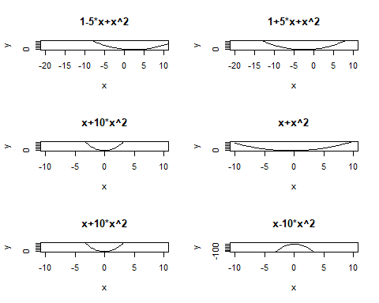

Graphs of two third-order polynomial models
#######third order
par(mfrow=c(1,2))
#beta3
eq=function(x){1+x+x^2+x^3}
curve(eq, xlab="x", ylab="y", ylim=c(-5,5), xlim = c(-5,5))
title(main="1+x+x^2+x^3")
eq=function(x){1+x+x^2-x^3}
curve(eq, xlab="x", ylab="y", ylim=c(-5,5), xlim = c(-5,5))
title(main="1+x+x^2-x^3")
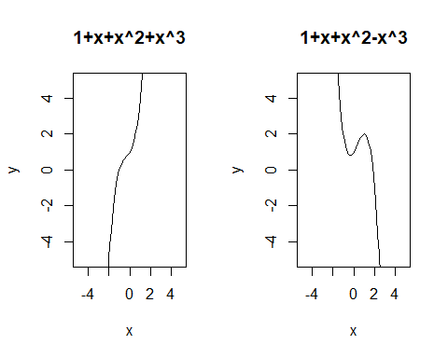

Example 5.2.1
Refer to the Cooling method for gas turbines data set.
####
GASTURBINE <- read.delim("GASTURBINE.txt")
View(GASTURBINE)
attach(GASTURBINE)
head(GASTURBINE)
## ENGINE SHAFTS RPM CPRATIO INLET.TEMP EXH.TEMP AIRFLOW POWER HEATRATE
## 1 Traditional 1 27245 9.2 1134 602 7 1630 14622
## 2 Traditional 1 14000 12.2 950 446 15 2726 13196
## 3 Traditional 1 17384 14.8 1149 537 20 5247 11948
## 4 Traditional 1 11085 11.8 1024 478 27 6726 11289
## 5 Traditional 1 14045 13.2 1149 553 29 7726 11964
## 6 Traditional 1 6211 15.7 1172 517 176 52600 10526

a) Construct a scatterplot relating heat rate to airflow. What type of model is suggested by the plot?
# Scatterplot
plot( x= AIRFLOW,y= HEATRATE, main="HEAT RATE vs. AIR FLOW", pch=19, col="blue",
ylim = c(8000, 20000), xlim =c(0, 800), xlab = "Air flow (kilograms per second)",
ylab = " Heat rate (kilojoules per kilowatt per hour)" )
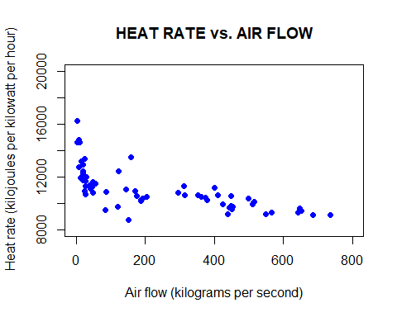

Interpretation
- The scatterplot suggests a nonlinear relationship.
- As airflow increases, the heat rate decreases rapidly at first and then levels off.
- This pattern suggests that a curvilinear (quadratic or cubic) model might be a better fit than a simple linear regression.
Thus, the expected model should include polynomial terms.

b) Fit the third-order model to the data for the heat rate (y) using AIRFLOW. Is there evidence that the cubic term, $β_{3}$ * $x_{3}$, contributes information for the prediction of heat rate? Test at $α$ = 0.05
# Model
model=lm(HEATRATE~AIRFLOW+I(AIRFLOW^2)+I(AIRFLOW^3),data = GASTURBINE)
summary(model)
##
## Call:
## lm(formula = HEATRATE ~ AIRFLOW + I(AIRFLOW^2) + I(AIRFLOW^3),
## data = GASTURBINE)
##
## Residuals:
## Min 1Q Median 3Q Max
## -1954.3 -655.3 -59.3 427.6 3302.1
##
## Coefficients:
## Estimate Std. Error t value Pr(>|t|)
## (Intercept) 1.301e+04 2.655e+02 49.015 < 2e-16 ***
## AIRFLOW -2.380e+01 4.946e+00 -4.812 9.7e-06 ***
## I(AIRFLOW^2) 6.267e-02 1.786e-02 3.508 0.000838 ***
## I(AIRFLOW^3) -5.295e-05 1.695e-05 -3.124 0.002697 **
## ---
## Signif. codes: 0 '***' 0.001 '**' 0.01 '*' 0.05 '.' 0.1 ' ' 1
##
## Residual standard error: 1038 on 63 degrees of freedom
## Multiple R-squared: 0.5958, Adjusted R-squared: 0.5766
## F-statistic: 30.96 on 3 and 63 DF, p-value: 2.022e-12
H0 : $β_{3}$ = 0
Ha : $β_{3}$ $≠$ 0
Since the p-value= 0.002697 < 0.05 for the above test, there is sufficient evidence of a third-order relationship between heat rate and air flow.

c) Write a complete second-order model for heat rate (kilojoules per kilowatt per hour)(y) as a function of cycle speed (RPM) and cycle pressure ratio (CPRATIO).
y = $β_{0}$ + $β_{1}$$x_{1}$ + $β_{2}$$x_{2}$ + $β_{3}$$x_{1}$$x_{2}$ + $β_{4}$$x_{1}^{2}$ + $β_{5}$$x_{2}^{2}$

d) Fit the model to the data and give the least squares prediction equation.
#####5.19
model519=lm(HEATRATE~RPM+CPRATIO+RPM*CPRATIO+I(RPM^2)+I(CPRATIO^2))
summary(model519)
##
## Call:
## lm(formula = HEATRATE ~ RPM + CPRATIO + RPM * CPRATIO + I(RPM^2) +
## I(CPRATIO^2))
##
## Residuals:
## Min 1Q Median 3Q Max
## -1196.10 -281.46 -34.99 302.94 1896.08
##
## Coefficients:
## Estimate Std. Error t value Pr(>|t|)
## (Intercept) 1.558e+04 1.143e+03 13.635 < 2e-16 ***
## RPM 7.823e-02 1.104e-01 0.708 0.48144
## CPRATIO -5.231e+02 1.034e+02 -5.061 4.11e-06 ***
## I(RPM^2) -1.806e-07 1.969e-06 -0.092 0.92724
## I(CPRATIO^2) 8.840e+00 2.163e+00 4.087 0.00013 ***
## RPM:CPRATIO 4.452e-03 5.582e-03 0.798 0.42821
## ---
## Signif. codes: 0 '***' 0.001 '**' 0.01 '*' 0.05 '.' 0.1 ' ' 1
##
## Residual standard error: 563.5 on 61 degrees of freedom
## Multiple R-squared: 0.8846, Adjusted R-squared: 0.8752
## F-statistic: 93.55 on 5 and 61 DF, p-value: < 2.2e-16
$\hat{y}$=15580 + 0.07823$x_{1}$ - 523.1$x_{2}$ - 0.004452$x_{1}$$x_{2}$ + 0.0000001806$x_{1}^{2}$ + 8.84$x_{2}^{2}$
When $x_{1}$ = RPM, $x_{2}$ = CPRATIO

e) Conduct a global F-test for overall model adequacy.
H0 : $β_{1}$ = $β_{2}$ = $β_{3}$ = $β_{4}$ = $β_{5}$ = 0
Ha : at least one $β_{i}$i $≠$ 0
F-statistic = 93.55 on 5 and 61 DF, p-value: < 2:2e-16
There is sufficient evidence to indicate that the model is statistically useful for predicting heat rate.

f) Based on the prediction equation, graph the relationship between heat rate and cycle pressure ratio when cycle speed is held constant at 5,000 rpm. Repeat part d when cycle speed is held constant at 15,000 rpm. Compare the two graphs, parts d and e. What do you observe?
###RPM is Constant
new1=data.frame(RPM=c(5000), CPRATIO=GASTURBINE$CPRATIO)
y=predict(model519, newdata=new1)
plot(x=CPRATIO,y=y, main = "Scatterplot of predicted Heat Rate and CPRATIO, RPM=5000",
ylab = "Predicted Heat Rate", xlab ="CPRATIO",
ylim = c(8000, 15000), xlim=c(0,40),pch=19, col="blue")
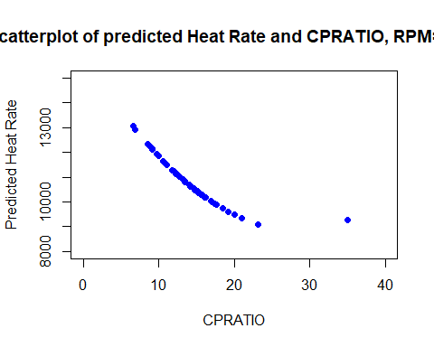
new2=data.frame(RPM=c(15000), CPRATIO=GASTURBINE$CPRATIO)
y=predict(model519, newdata=new2)
plot(x=CPRATIO,y=y, main = "Scatterplot of predicted Heat Rate and CPRATIO, RPM=15000",
ylab = "Predicted Heat Rate", xlab ="CPRATIO",
ylim = c(8000, 15000), xlim=c(0,40),pch=19, col="blue")
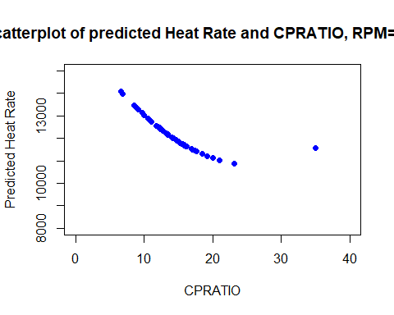

Interpretation
- Both curves show a similar shape (curved, decreasing).
- Only a vertical shift is observed—the heat rate values are different, but the overall trend remains the same.
- This suggests that the effect of CPRATIO on Heat Rate is the same at different RPM values, meaning there is no interaction effect.

